Spatial Analysis: Vector – Clip and Select
Materials needed: massachusetts.shp, US_census_tracts.shp
[1] Open and examine the data:
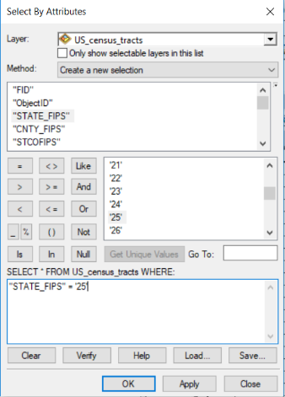
Open ArcMap and use the Add Data 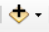 button to add both shapefiles to the map. Right-click > Open on the census shapefile to open the table. Take a moment to inspect the field (column) names and the values beneath them. At the bottom of the table, note that there are 73,682 records, each representing one census tract. Now do the same for the outline of Massachusetts. There is not much information there, but the number we need is the State FIPS number: 25. In the full census shapefile, only the tracts with FIPS 25 are in Massachusetts.
[2] Our goal is to create a new shapefile containing only the Massachusetts tracts. As we did in the Mapping Tabular Data Lab, use Select by Attribute to select only the census tracts with State_FIPS = 25.
Remember to fill in the calculator formula by clicking on choices, rather than typing them in, to get the proper syntax. As expected, the Massachusetts tracts are highlighted.
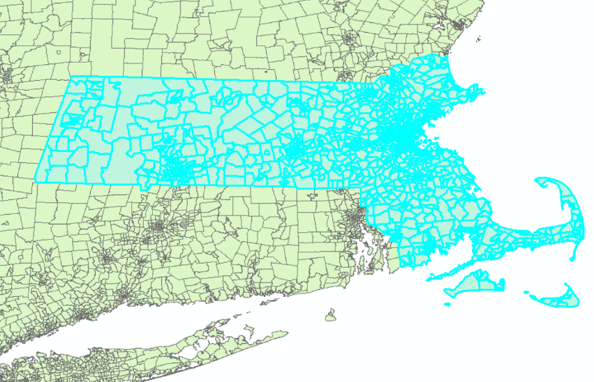
Right-click > Data > Export, with the top drop-down set to “Selected Features” is one way to create the new shapefile we want.
This lab exercise will teach you another method.

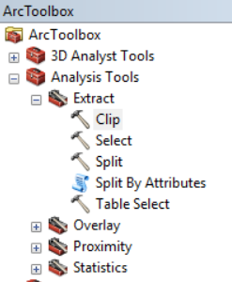
[3] Use the Clear Selected Features button to clear your selection. Then, use the ArcToolbox button to open the toolbox, if it’s not already open. Navigate to Analysis > Extract > Clip.
The Clip tool works like a cookie cutter. It needs two inputs: the larger Input layer that needs to be cut down, and a Clip layer to do the cutting.
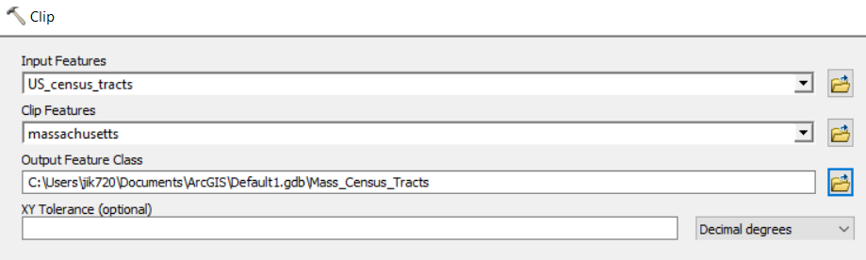
Name your output Mass_Census_Tracts and run the tool. The output will be the same as the earlier selection.
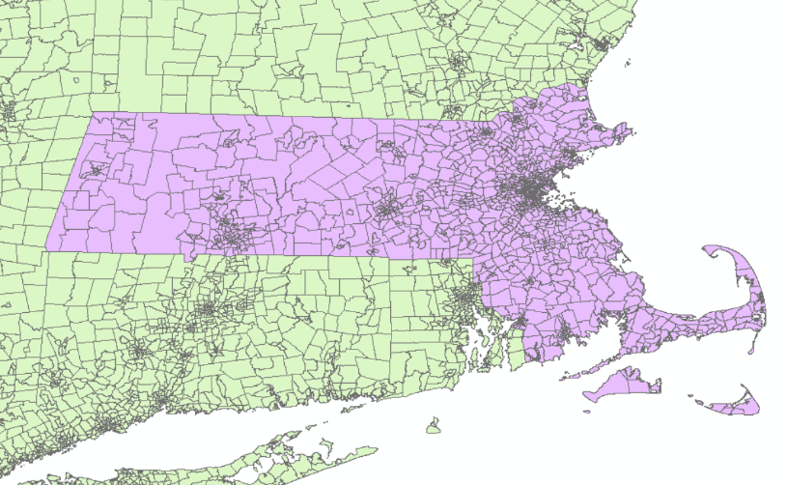
Clipping is a good technique to use when there is no common attribute to select by or when you need a purely spatial subset of a layer. Note: the Clip layer has to be one or more polygons, but the Input layer can be any vector layer. There is a separate Clip tool for rasters.
Notice that the Attribute Table for the output layer retains no information from the Clip layer.

Spatial Analysis: Vector – Buffer
Materials needed: Mass_Census_Tracts.shp, hospitals.shp
[1] Add the hospitals shapefile to the map and turn off or remove the full US_census_tracts layer for simplicity. In Drawing Order, drag the hospitals on top of the census tracts so you can see them.
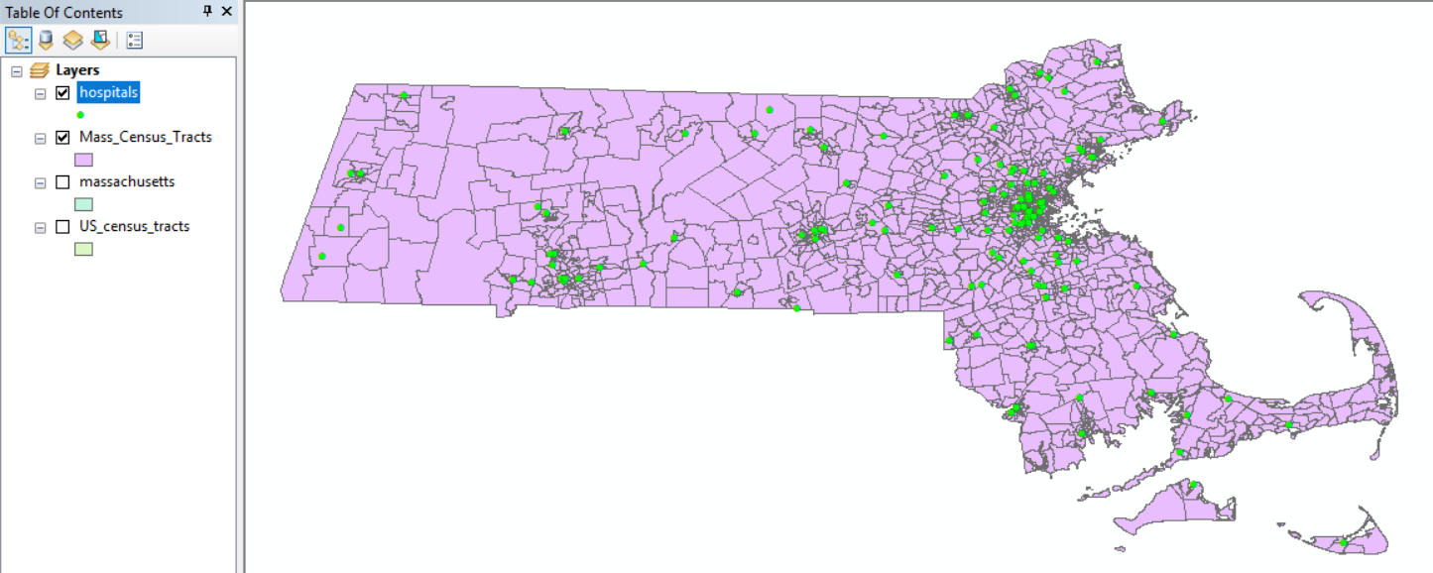
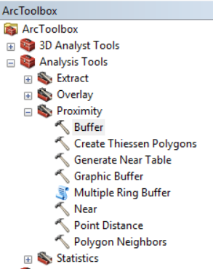
[2] Suppose we would like to know what parts of Massachusetts are within 5 miles of a hospital. The Buffer tool will draw regions that mark off a distance from each, or from the nearest, hospital.
In the toolbox, navigate to Analysis > Proximity > Buffer and launch the Buffer tool.

The input layer is the Hospitals. The output name can be hospitals_buffer. Type 5 in the Linear Unit box.
You will notice that the default units for Distance are Decimal Degrees. That is because these layers are in the WGS 84 coordinate system, and because they are all we added to the DataFrame, that also defaults to decimal degrees. Best practice is to use distance-based tools, such as buffer, in a distance-based projection such as Massachusetts State Plane. But, ArcMap will make the adjustment for us, for the purposes of this exercise. Just change the dropdown to “Miles.”
Also set the Dissolve Type to ALL. If Dissolve is set to NONE, we will get individual discs around each hospital point. All will blend those into irregular blobs indicating land that is within 5 miles of any hospital, not a particular one. Click [OK] to run the tool.
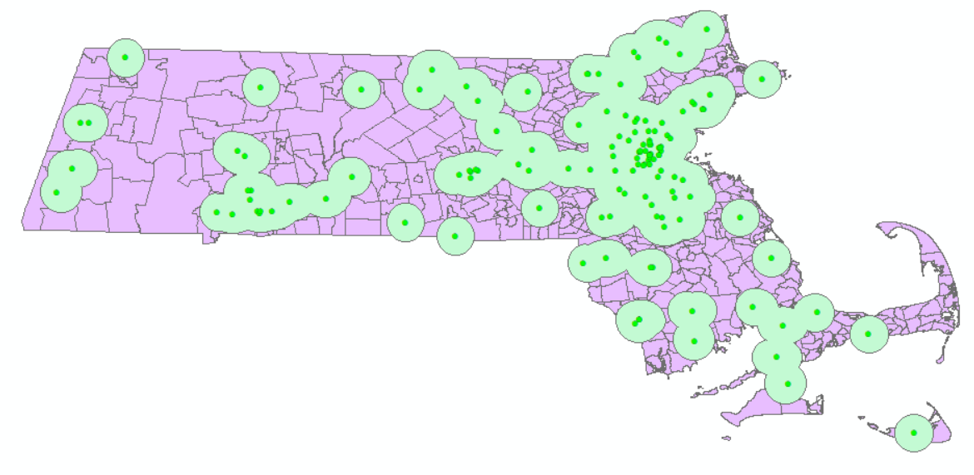
It is also possible to create buffers of different distances, based on the values in some field in the Attribute Table. To do so, you would use the Field option instead of Linear Unit.
Notice that the Attribute Table for this buffer layer has only one entry. All of these blobs are combined to make one multi-part polygon. You could split it up with a tool called Multipart-to-Singlepart if needed.

Spatial Analysis: Vector – Intersection
Materials needed: Mass_Census_Tracts.shp, hospitals_buffer.shp
[1] Suppose we were conducting an analysis of how many Massachusetts residents live within 5 miles of a hospital. We have the distance information in the buffer layer and the population information in the census tracts. The Intersect tool will extract only the areas where the two overlap.
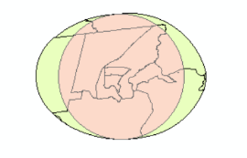
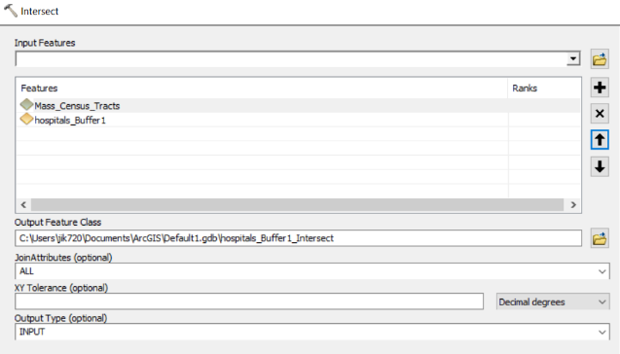
[2] Navigate to Analysis > Overlay > Intersect and launch the Intersect tool. Add both the hospital buffer and the census tracts to the inputs. The order matters because the projection of the first input will be used.
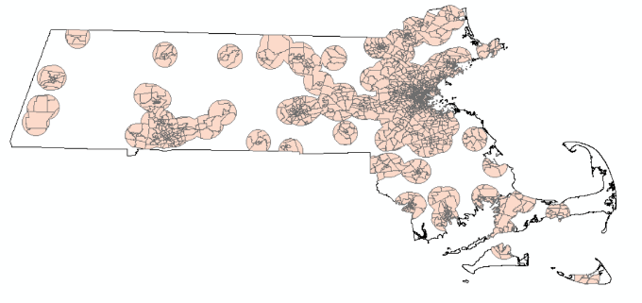
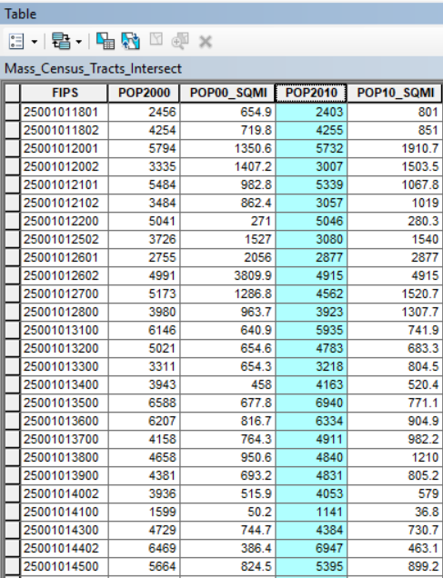

[3] Examine the Attribute Table. There is a field for population, but that field has just been copied from the original. It has not been adjusted to represent the partial census tracts in the intersection!
Extra Practice: To make the adjustment would require adding a new field and calculating (using Field Calculator) the ratio of the areas of the partial census tracts to the areas of their originals. Then multiply that fraction by the whole-tract population. Consider trying this exercise later on your own.

Spatial Analysis: Vector – Union
Materials needed: Mass_Census_Tracts.shp, hospitals_buffer.shp
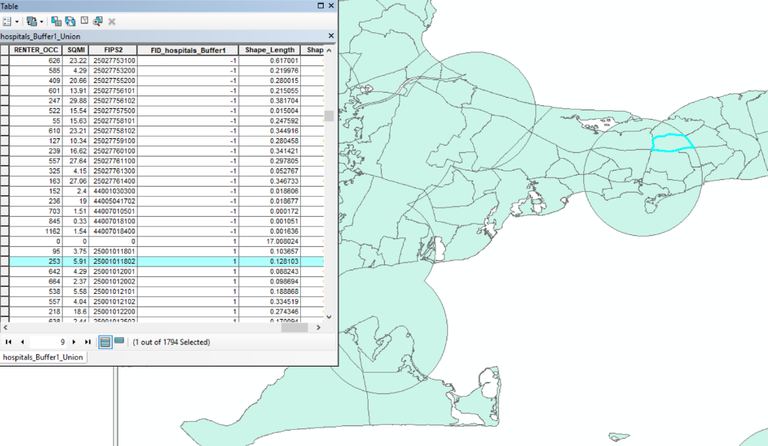
[1] The Union tool combines two or more layers in a way that keeps everything, rather than excluding anything. Navigate to Analysis > Overlay > Union and launch the Union tool. As before, add the input layers in the order shown.
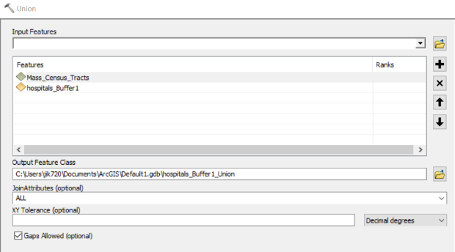
The output of Union can be a little hard to parse. There are now more small pieces of the original census tracts, as well as pieces and the entirely of the buffer multi-polygon.
One useful field in the output is a column of 1’s and -1’s which indicates whether a polygon originally fell in the buffer layer or not.

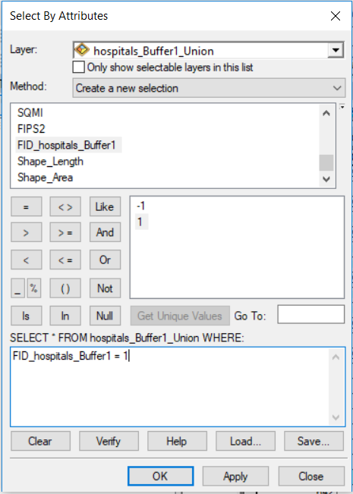
We can use that column to explore whether the population living within 5 miles of a hospital is different from the population living further away. We will explore if they differ in age.
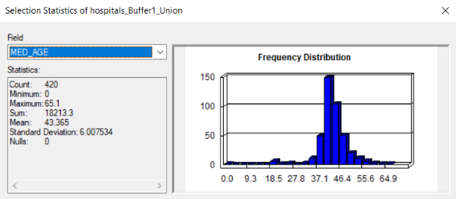
Use Select by Attribute to select the polygons within the buffer zones. In the Attribute Table, right-click on the MED_AGE column and choose Statistics. Then switch the selection to those outside the buffer zones and repeat the Statistics. The average median age is younger in the zones close to a hospital.
