Preliminary: Under the Customize menu, choose Extensions and check the box by the Spatial Analyst extension.
Spatial Analysis: Raster -- Slope
Materials needed: frack.mxd (a complete map document) and frack.gdb (a geodatabase containing the needed layers)
[1] Open and examine the data:
Open ArcMap, and in the file menu, find Open. Navigate to frack.mxd and open it. If the layers appear with small red exclamation marks, [!] repair the links by clicking on one such mark and navigating to that layer in frack.gdb.
The following layers appear in the Table of Contents: (explore by turning them on and off and viewing Attribute Tables)

Wells – a point layer of existing fracking wells
Roads – a line layer of the major roads
Counties – the outlines of eight counties in Pennsylvania
NLCD11 – National Land Cover Data from 2011, each color is a category of land cover
NLCD_AG – the same Land Cover data, where every category has been set to 0 except Agriculture (1)
DEMs – “Digital Elevation Model,” a layer showing elevation
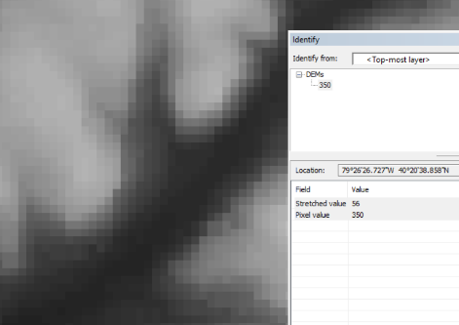
Turn off the County labels by right-clicking on the layer name and unchecking “Label Features.” Turn off or re-arrange layers so that you can see the DEM. Zoom in until you can see the pixels and use the Identify Cursor
to view some of the pixel values. Zoom back out to the full layer.

[2] For every cell, the Slope Tool will calculate the greatest “steepest” difference between the cell’s elevation and that of its neighbors. Open ArcToolbox using the toolbox icon. Then go to Spatial Analyst > Surface > Slope and launch the Slope tool.

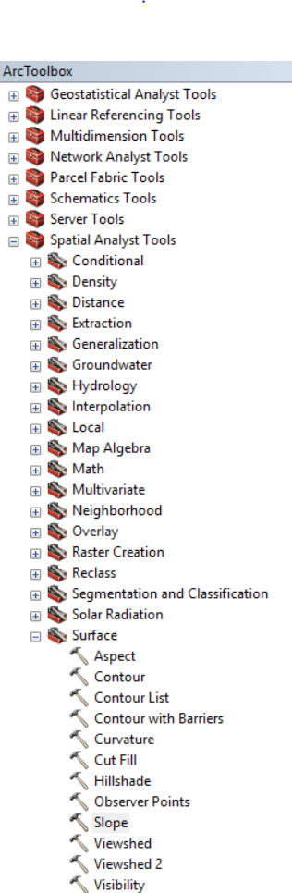
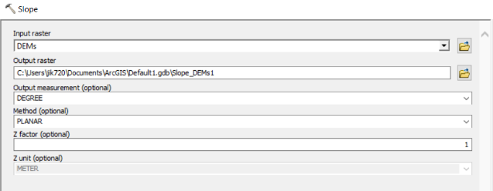
Choose DEMs as the input layer. You may set the output directory to anywhere you choose. Name the output Slope_DEMs and run the tool.

Change the symbology to Classified, Quantile with 7 classes.
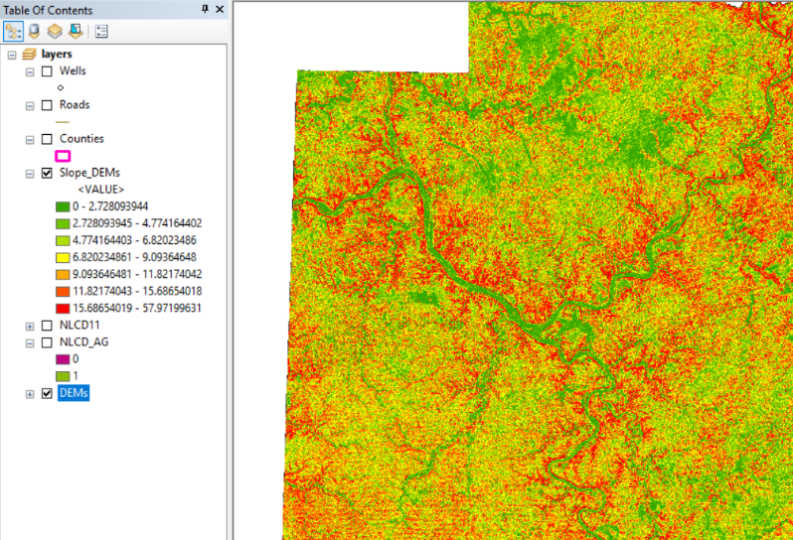
The units in the Table of Contents are degrees. You will notice that the surface of the rivers is very level (green) while their banks are steep. Mountainsides are also rather steep.
We can probably assume fracking companies would want to place wells on more level terrain.

Spatial Analysis: Raster – Distance
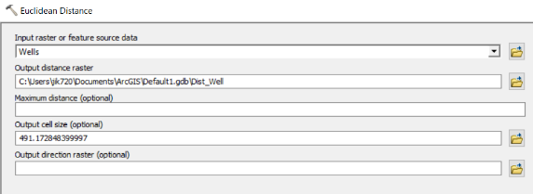
Turn off the Slope_DEM layer and turn on the Wells layer. The Euclidean Distance Tool will compute, for each raster cell, how far it is from the nearest well. In the Toolbox, go to Spatial Analyst > Distance and launch the Euclidean Distance Tool. The input layer is Wells. This input layer can be a vector layer or a raster layer, but special considerations must be taken when it’s a raster layer.
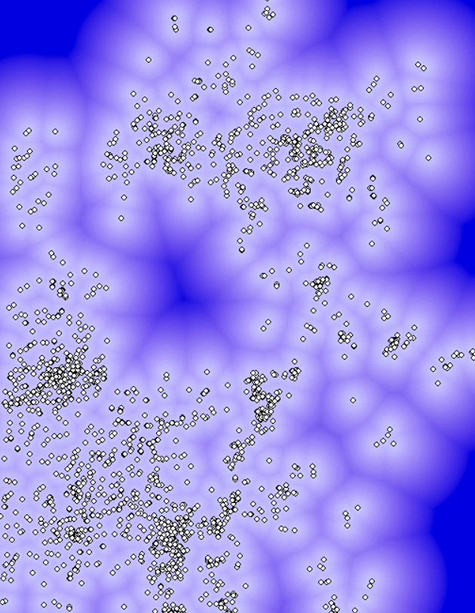
Set the output name to Dist_Wells and run the tool. Change the symbology to Stretched for a nicer image.
In the color scheme displayed here, the dark blue areas are furthest from any well. The Inspector Cursor will reveal how many meters any location is from its nearest well.
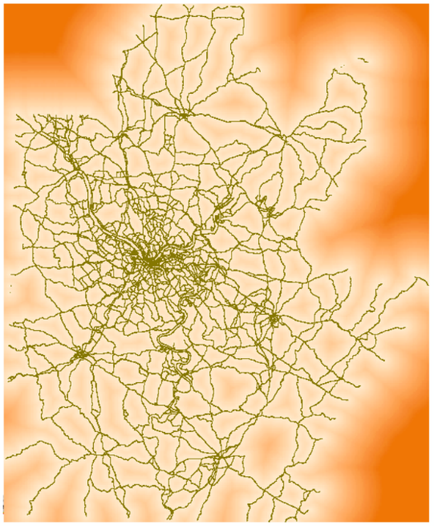
We can assume that fracking companies would locate a new well close to others, since that is where the gas is.
Repeat this exercise to create a layer showing distance to the Roads.
We can assume that new wells would be located close to major roads, to make it easy to transport the gas they extract.
The final exercise in this lab will attempt to predict likely locations for new fracking wells to understand which agricultural lands might be at risk from fracking. We will develop a formula to compute an index based on the slope of the terrain and the distance to existing roads and wells. The highest values of the computed index will be the most at-risk for fracking development.
But before that, we should re-scale the slope and distance factors so that more desirable pixels have higher values. We can “reclassifly” the slope and distance rasters to a five-point scale.

Spatial Analysis: Raster – Reclassify
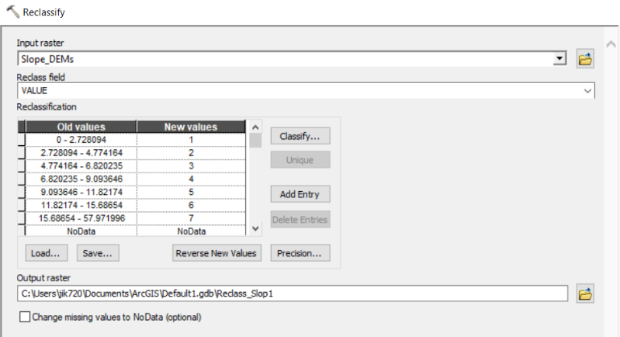
First, reclassify the slope layer by navigating to Spatial Analyst > Reclass > Reclassify. When you choose Slope_DEM as the input layer, the Reclassify Tool automatically takes a guess at how you might want to change the raster’s values – from degrees to a 7-point scale.
We would prefer a 5-point scale, and the new values run backwards – low slopes (flat) are given low scores.

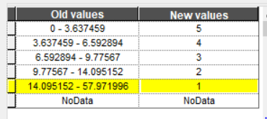
To change the value ranges, click Classify. The same window that allows you to classify raster symbology appears. Change the classification to Quantile with 5 classes. Click ok, and then hand-type new values in descending order in the Reclassification box. Save the output as Slope_reclass and run the tool.
Repeat this exercise with the roads. Change the classification to quintiles and give lower distances higher scores.
When you are done, you will have three reclassified layers. We will use those and the NLCD_AG layer to determine which agricultural lands are at risk from fracking.
Spatial Analysis: Raster – Map Algebra
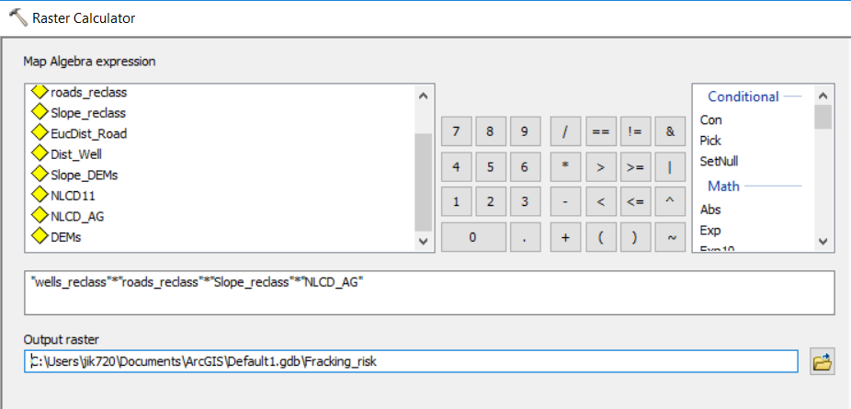
Now we will create the formula that combines all four layers. Go to Spatial Analyst > Map Algebra and launch the Raster Calculator. We will multiply the four layers together to get a score that indicates fracking risk, based on these four variables. Enter the following formula by clicking the layer names from the list (rather than typing them in).

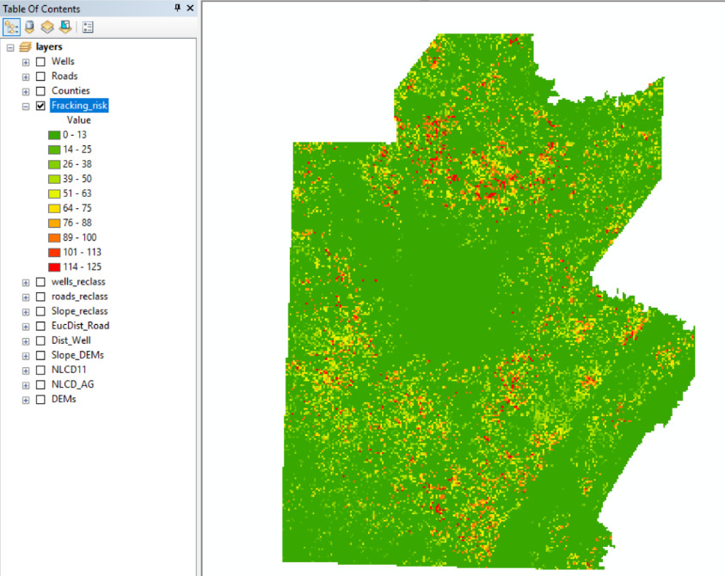

Notice that all of the non-agricultural lands will have the value zero in the output because of the multiplication.
Here, the symbology has been changed so that the areas most at risk are colored red.

Extra: Zonal Statistics
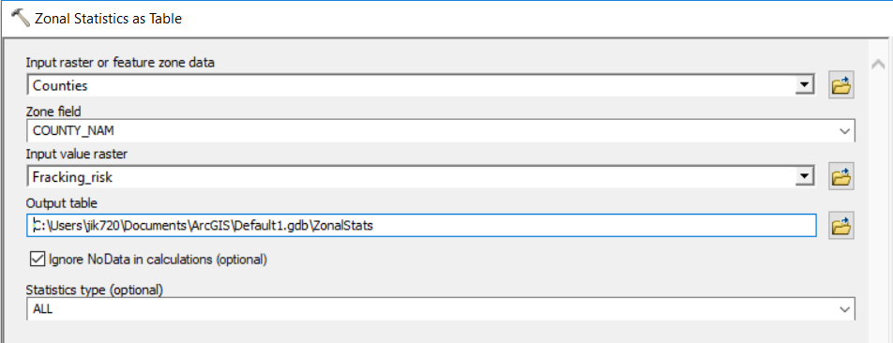
Now turn back on the counties layer. The Zonal Statistics Tool can create a statistical summary of the risk per county.
Go to Spatial Statistics > Zonal and launch Zonal Statistics as Table. Zonal Statistics needs two inputs: a raster layer to be summarized and a layer of “zones” – in this case counties – giving the units to summarize over. The Zone Field can be any field that has a unique value for each zone.

The output of Zonal Statistics as Table is . . . a table! But that table can then be joined, using County Name as a key, to the counties layer.
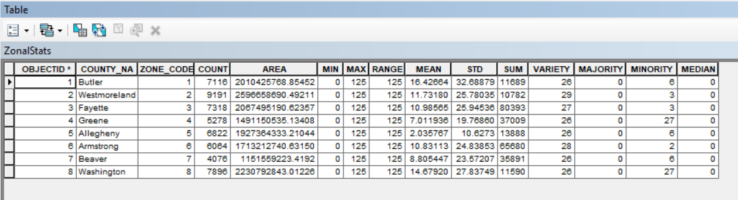

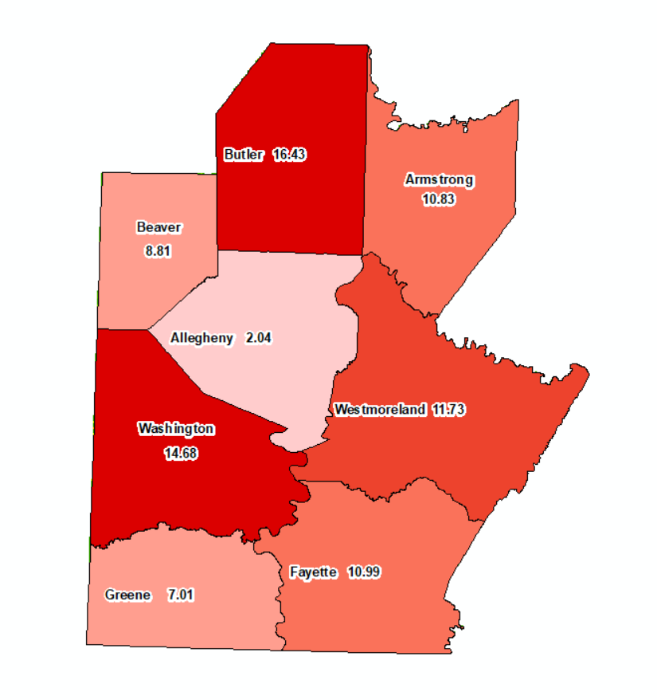
The newly joined layer can then be colored according to the mean value of the risk index for each county.

