US States and Capitals Map Lab: Using Type and Effects in Adobe Illustrator

Objectives: To create a polished map using ArcMap and Illustrator that includes effects.

When designing and creating a map, it is essential to consider the purpose, audience, and medium for the map. For this exercise, you are a cartographer tasked with creating a map to be used by 5th grade students living in Columbia, South Carolina, who are studying U.S. Geography. In particular, your map is intended to 1) help the students learn US State and Capital names and locations, and 2) Emphasize where South Carolina and Arizona are, since this class will be taking a field trip to the Grand Canyon in Arizona for spring break. So, here are your initial design parameters:

Purpose: To show where US States and Capitals are, and to highlight South Carolina and Arizona.
Audience: 5th graders.
Medium: Print, 8.5 x 11, color.

Part I. Download a US States shapefile and set the map projection
A shapefile is a file that stores geographic information for use in GIS software. There are thousands of shapefiles out on the web available for download and usage. The file extension used for a shapefile is “.shp”. However, a shapefile also contains the associated “.dbf” and “.shx” files at a minimum (there may be more). To work in GIS, these associated files must be in the same folder, and have the same name before the dot. Keep this in mind when downloading shapefiles…..a shapefile has more than one file!

Let’s get started
- Download a US states shapefile from the web.
Open an internet browser, and do a Google search for “US States Shapefile”. One of the top search results should be “ArcGIS.com | Shapefile – states basic”. Click this link (see below).
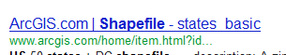
On this ArcGIS.com website, click the Open button and choose Download. Save and unzip the contents of this zip file into your Lab2 folder. Make sure to note the source of this shapefile is ArcGIS.com, you’ll need this later when putting data citations on the map.

- Add the states shapefile to ArcMap.
Open ArcMap, and click File > Add Data > Add Data. Click the Connect to Folder button. Click Computer > and browse to your Lab2 location, and click OK. Double click the States shapefile to add it to the map.
- Change the coordinate system of your map.
When adding a shapefile to a blank map document, the document’s coordinate system is set to that of the shapefile. To check the coordinate system of a shapefile, right click it in the Table of Contents (TOC), choose Properties, and the Source tab. Do this on the states shapefile and note that it is in the Geographic Coordinate System: GCS_WGS_1984 coordinate system. In ArcMap, all geographic coordinate systems are projected using a cylindrical projection based on the Equator. This has the effect of stretching features in the east to west direction the further you move away from the Equator. We want to change the map to use a Projected coordinate system that is meant for the Lower 48 United States.

To do this, Right click the word Layers in the TOC, and choose Properties. Click the Coordinate Systems tab. In the search window at the top, type in “usa” and hit enter. Choose the Projected Coordinate System > Continental > North America > option and choose any of the “USA Contiguous” options. Click OK and your map will change to this coordinate system.

- Save your map.
Click File > Map Document Properties > check the box next to “store relative pathnames….” > OK. Then click File > Save As, and save this map in your Lab3 folder (choose any name that is self describing, putting it in your Lab2 folder).

- Get rid of Alaska and Hawaii
For simplicity’s sake our map is to be of the lower 48 states, so let’s remove Alaska and Hawaii from this shapefile. Right click your states layer and choose Zoom to Layer.
Right click on the states layer and chose Edit Features > Start Editing. Click OK to the “spatial data does not match reference data frame” warning. Use the Edit tool from the Editor toolbar: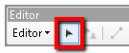and click on Alaska on the map, hold the shift key, and click on Hawaii. Click Edit and Delete. The states will disappear from the map. On the Editor toolbar, click Editor > Stop Editing, and click Yes when prompted to save.

- Add the Capital cities.
Add the USA_Capital_Cities shapefile from the GPH_946_Lab2\Data folder.

- Inspect your cities and states layers, and label them.
Right click your USA_Capital_Cities layer and Open Attribute Table. Note that the NAME field contains the capital city names, and this is what we want to label the map with. Close the attribute table.
Right click the Capital_Cities layer > Properties, and choose the Label tab. Click the Placement Properties button. In the Placement Properties dialog, choose the Conflict Detection tab and check the box next to Place overlapping labels. Click OK. Usually we don’t want labels to overlap. But in this case it will ensure all labels are placed on the map, so we can export them all into Illustrator. Back in the Layer Properties window, Labels tab, Click the checkbox next to “Label features in this layer”. Click OK, and now all of the labels will appear on your map. Note how cluttered they are! ArcGIS actually has many tools to make labels look better, but working with type is much easier in AI. Repeat the steps above on your States layer to label the full state names on your map.

- Symbolize your states and capitals
The symbology chosen by ArcMap by default is random. Let’s change the states and cities to more standard symbols. In the TOC, click on the dot under the Capital_Cities layer to bring up the Symbol Selector. Choose the “Circle 1” symbol with a size of 8 and click OK. This will change your cities symbols to simple black circles. Click on the rectangle under the States layer, and symbolize this with No Color as the fill, and a black line with weight of 1.

- Export your map for use in Adobe Illustrator.
Click View > Layout View. Use the Zoom tools to display most of the page space with your map. It should look similar to the screenshot below:
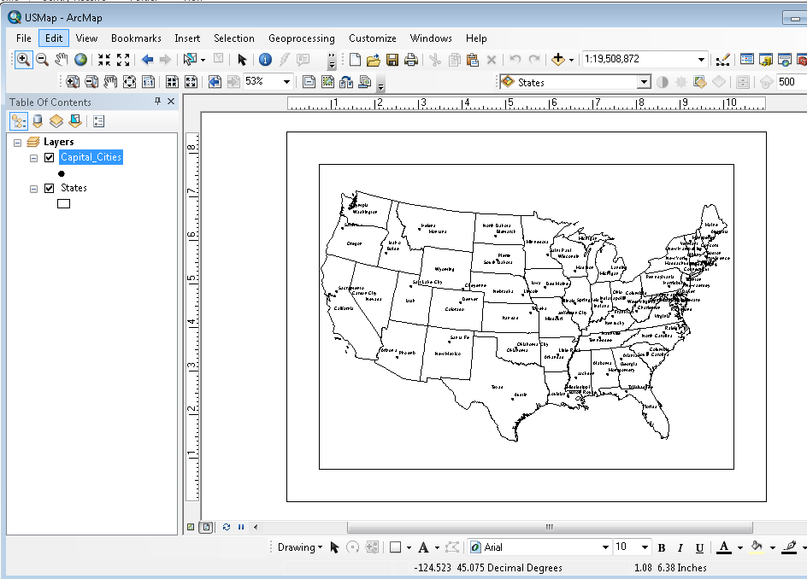

Click File > Export Map. Specify the Save as type to “AI”. Choose the Format tab on the bottom, and check the box next to “Convert marker symbols to polygon”. Save your file in your Lab2 folder, naming it USMap_YourName.ai. Now it is time to open the map in AI, and work with it there to improve the labeling on the map.

Part II. Polishing your Map in Adobe Illustrator
Now it is time to employ type setting techniques to make a map with great looking labels. You’ll need to perform the following tasks in AI to achieve this.
Start Illustrator, and click File > Open. Browse to your USMap_YourName.ai file, select it, and click Open. When opening the map in AI, make sure to choose Update on the screen shown below:
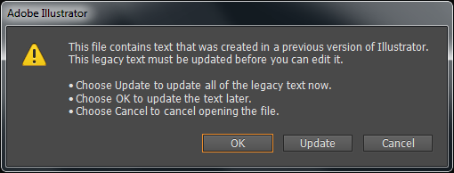
The first thing to do is get rid of the “Clipping Paths” that added to the document unnecessarily. To do this, follow the instructions in this video: http://screencast.com/t/3Gqbq4O7
Make sure the volume on your computer is turned up.
One more thing to be aware of when working with this map in Illustrator is that many of the objects (individual states, and state labels) may be grouped. This means that to interact individually with one object, you must select the objects that are grouped with the selection tool, then right click on the objects and choose Ungroup. Now you can select off of the objects you just ungrouped. Then when you select an individual object it will be the only one selected.

Then it is time to inspect the layers in your document, and get to know the objects each layer contains. Open your Layers window by clicking Window > Layers. The Layers window will open up, it should look like this:
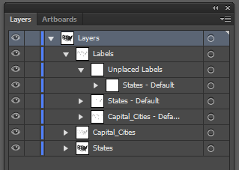
In class this week your Instructor will demo how to view, unlock, and select all elements within one of your AI document’s layers. Now it is time to set the type (state and capital city labels) on this map. While doing this, adhere to the typographic principles outlined below. Use the Character Window (accessed with Window > Type > Character) in Illustrator to fine tune your labels. This is what the map will be graded on – the bulleted criteria listed below (1 point each):

Positioning all of the City labels using these conventions:
- San serif font, all 48 labels present
- No overlap with other labels
- Minimizing overlap with state boundaries. Where there is overlap, adding a “halo” (Right click the label, and choose Create Outlines. Then make the stroke weight very small)
- Default label placement to the upper right
- Multiline labels left justified if placed to the right of the city dot; right justified if placed to the left, centered if placed above or below.
- Use of leader lines, or abbreviations in crowded areas (Northeast)

Positioning all State labels using these conventions:
- Same font as Cities, all 48 labels present
- Use all capital type (do this by selecting all labels > Type > Change Case > UPPERCASE
- Proper use of kerning (character spacing) to spread names across large states
- Use of leader lines in crowded areas (Northeast)
- No overlap with other labels
- Minimizing overlap with state boundaries. Where there is overlap, adding a “halo”

Additional type to add, in the proper geographic positions:
- “Pacific Ocean” – with kerning, leading, serif font, italicized
- “Atlantic Ocean” – with kerning, leading, serif font, italicized
- “Gulf of Mexico - with kerning, leading, serif font, italicized
- “CANADA” – with kerning, serif font, and rotated to follow the US/Canada border.
- “MEXICO” – with kerning, serif font, and rotated to follow the US/Mexico border.
- “Ohio River” – splined, with kerning, and serif font.
- “Mississippi River” – splined, with kerning, and serif font.
(There’s no rivers layer on the map, but the state borders define most of the length of these rivers)

Color:
- Shade the US States different than the background of the map, so there is some contrast.

Effects:
- Add an effect to the US States to “jazz it up” a bit. Click the Effect option, and experiment with different effects. Click Edit > Undo (or Ctrl + Z) to undo effects you don’t want (2 points).

Emphasis:
- Use perspective height to emphasize South Carolina and Arizona. This is accessed by selecting one of these states, and then Effects > 3D > Extrude & Bevel. Experiment with different rotation and perspective values, and view the desired effects (2 points).

Overall:
- Use this visual hierarchy: 1)Arizona and South Carolina, 2) Capital Cities, 3) State names / all other type. Inclusion of a map title (2 points).
- Include your name, logo created in Lab1, and data source citation (ArcGIS.com for the states shapefile) (2 points).
- Be creative, make your map unique! Include the logo you designed in week 1. Also make your map legible and able to communicate the purpose (2 points).

When your map is complete, export it from Illustrator into .jpg format, naming it USMap_YourName.jpg.

