Working with Layouts

Layout view is where you create a readable and useful map. Effectively applying design principals will allow your map to better communicate information. To enter layout view click the icon at the bottom left of the workspace in ArcMap.
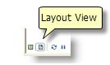
Inserting Elements into Your Layout
- Click Insert from the top menu (figure 1). Here you can insert North Arrows, Legends, Scale Bars, Titles, Neatlines, and Texts.

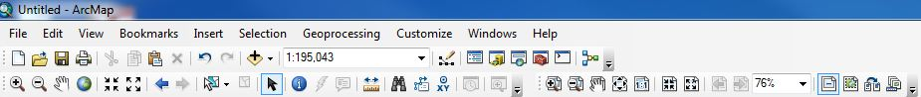
Figure 1
- Keep in mind you can (and should!) edit all of these elements once you have inserted them. Typically this is done by right clicking the element and choosing Properties. For instance, if your map is of Canada your scale bar should be in Kilometers instead of Miles. Your legend headings should relate to what the symbols are representing. Your fonts should be readable and appropriately sized. There are several cartographic decisions you need to make in layout view and you should consider them all carefully.
- If you choose you can add a basemap by clicking the drop down arrow beside the add data icon (the plus sign) and choosing add basemap.
- Necessary text that you should add to your map:
  - A text box that states the projection you used
  - It is also often helpful to include what classification you used and the unit of analysis
  - A reference to where you obtained the data that includes the date of the data
  - Your name as the map maker
  - The date the map was created
  - A title for the map and a title for the legend/classes
  - Any other information that is necessary or helpful in reading and understanding the map
Resizing and Moving Data Frames and Map Elements
- Each data frame and added map element will be in a separate moveable box in layout view. You can resize and move these using the corner arrows.
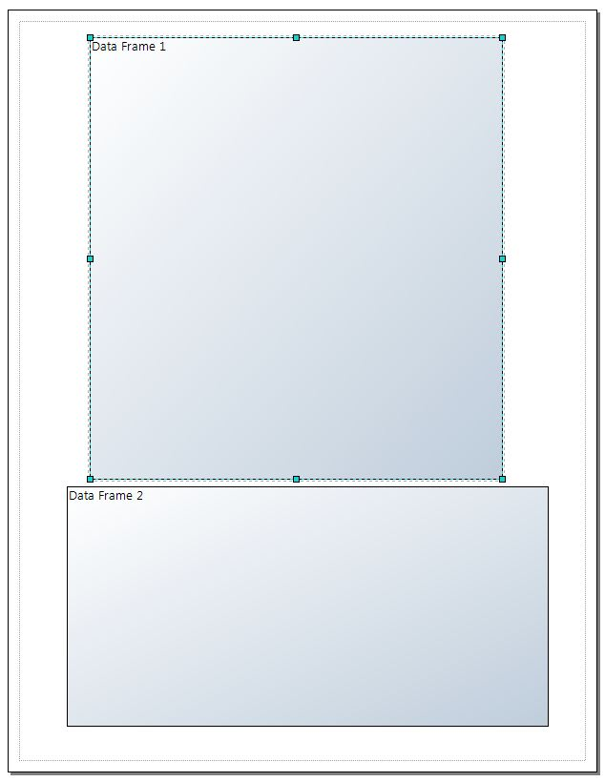
Figure 2
- When a data frames is highlighted (like Data Frame 1 is in figure 2, it is activated)
- You can also resize and move your data frame(s)/other objects by right clicking them and choosing nudge, align, distribute, rotate or flip. If you highlight one or more objects and right click, you can make them the same size, align them, distribute them evenly etc. Experiment with these tools, as using them can make creating precise layouts quicker and easier.
- You can also click View (figure 1) from the top menu and choose Grids, Guides, and Rulers to help you align elements in your layout
- When you are moving and resizing elements keep hierarchy, balance, and figure ground in mind! Which elements should the reader’s eye be drawn to? How can you best fill empty space?
Changing from Portrait to Landscape
- Depending on the shape of your mapped data you may want to change the orientation of your layout
- To change from portrait to landscape view, click FilePage and Print Setup and change the orientation to landscape.
Symbols, Colours, and Transparency
- Keep in mind how your symbols look in the context of your layout. You can edit the symbology in layout view the same way you did in data view (right click the layer and choose properties). Are your symbols discernible? Do your colours make sense? Are the units and classes clear from the legend?
- You can edit colours beyond the colour scales given by ArcMap. Click the drop down arrow beside an individual colour and click More Colours. Here you can edit the specific RGB, HSV, or CYMK numbers of the colour. Visit Colour Brewer, http://colorbrewer2.org/ to explore more colour schemes. You can use these colour schemes for your map by typing in the RGB numbers.

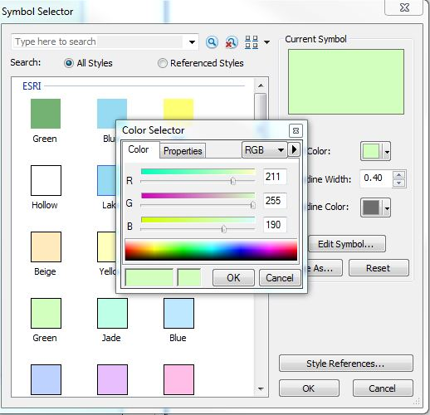
Figure 3

- Setting Transparency can be useful when you are displaying many layers on top of each other. Right click a layer and choose Properties, then click the Display tab from the top of the window. Set a percent for transparency and click OK.
- If you want to set transparency for a basemap you need to click customize from the top menutoolbarseffects. In the effects toolbar you can adjust transparency.
For more information please visit:
http://resources.arcgis.com/en/help/main/10.1/index.html#//00s900000007000000
http://resources.arcgis.com/en/help/main/10.1/index.html#/Map_elements/00s900000002000000/
http://resources.arcgis.com/en/help/main/10.1/index.html#/A_quick_tour_of_displaying_layers/00s500000019000000/

