Labels and Annotation
The following document contains guidelines for creating dynamic labels as well as annotations. The area of focus used for this tutorial is of central Saskatoon (business district and University area).

Label and Map Preparation
Maps used to convey accurate spatial locations should be projected.
To check and/or edit your map’s coordinate system:
- Data Frame Properties → Coordinate System tab → Projected Coordinate Systems folder and find one that best suits your area. UTM →North America → NAD 1983 (2011) UTM Zone 13N
Figure 1 shows the default labels for the schools, healthcare facilities, and neighbourhoods. The labels clutter the map and are sometimes in an inaccurate location. Figure 2 shows the same map after editing label properties, placement, size, colour, and converting them to annotation for further modification.
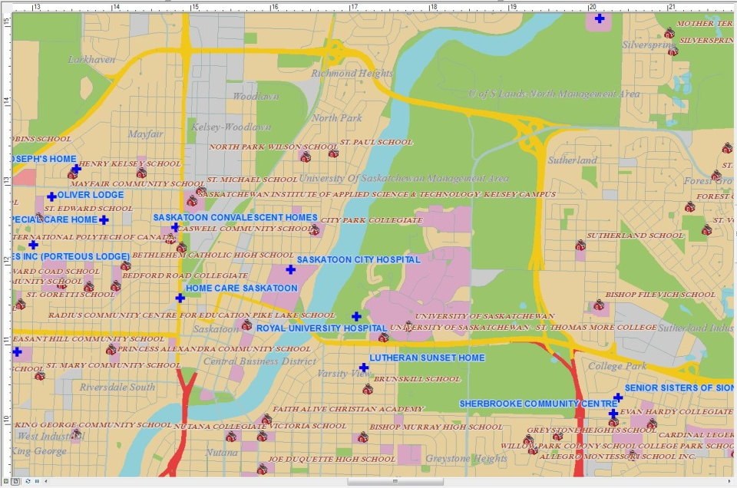
Figure 1: Central Saskatoon in layout view before editing label properties

In order to add more categories to the healthcare and education layers, a new field was added to the attribute table called ‘Type’. A new name field, ‘Name_2’ was created, so that the labels would be proper case rather than upper case.
Adding a new field to an attribute table:
- Open the attribute table and the first icon along the menu bar has a drop down arrow, click on it and find Add a Field… as in Figure 3. Here two text fields, Type and Name_2, were added. Ensure to make the precision of the field large enough for the longest entry i.e. the precision would be 50 for “University of Saskatchewan St. Thomas More College”.
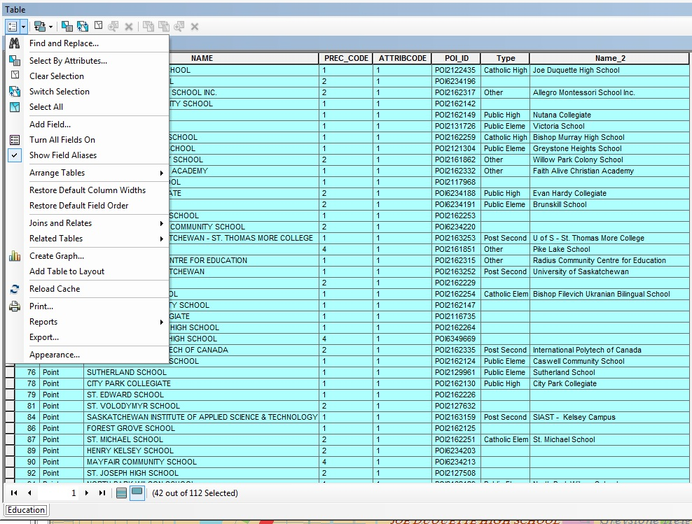Figure 2: Adding a field to the attribute table

Field Calculator:
The following link contains field calculator short cuts, which you will need to use to populate the new field that you have created. When using the Field Calculator, ensure that you use the Type (Number, String, Date) specified.
http://www.esri.com/news/arcuser/0405/files/fieldcalc_1.pdf
Editing symbol properties:
In the Layer Properties window, choose the Symbology tab and change the symbol of the label, the colour, and the size, if needed. You can further modify the symbol (halo, angle, etc) using the edit symbol button. See Figure 4.
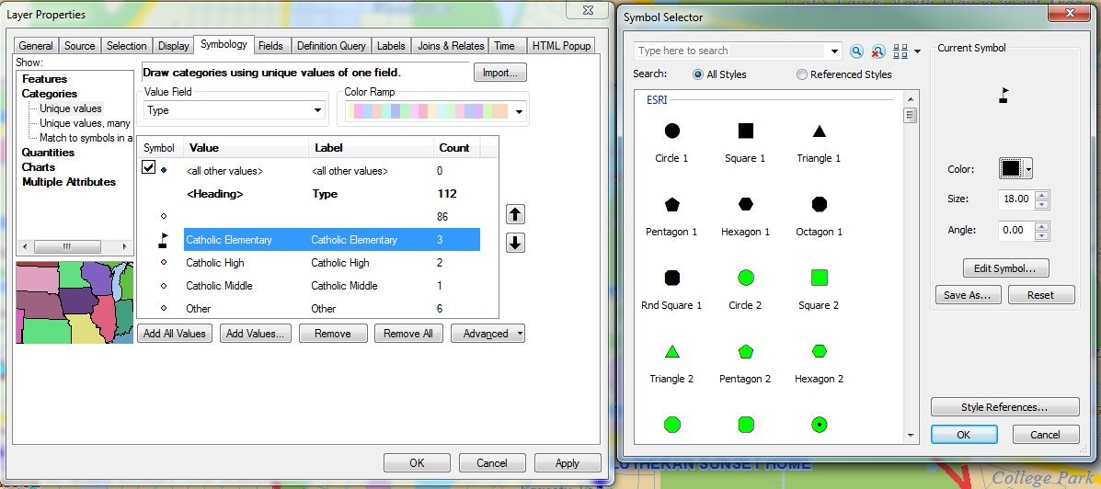Figure 3: Layer Symbology and Symbol Properties

Saving a Custom Colour:
If you have found a colour that you particularly like, and would like to save for future use with this map file, you can save a custom colour.
- Open the colour properties (most shape/line/label/symbols are able to have a custom colour)
- Under the table of colours appears “More Colors…” and create the colour you desire (either from a set of RGB or HSV or CMYK).
- Inside this new window, click the right arrow and save the colour. You can name it – in this instance it may be “cath elem” for catholic elementary school.
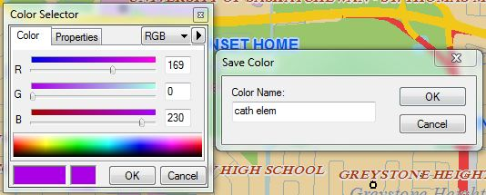
Figure 4: Saving a Custom Colour

Label Properties:
In order to make the map readable and discernible before converting the labels to annotations, you will want to edit the layer’s label properties. Go to the label properties of the layer you wish to edit, and under the “Label” tab, you can change the method of labelling, the field on which to base the labels (Name_2 created earlier), the label aesthetics, label placement, scale range (for zooming), and you may select a pre-defined label style (or you may also choose to create your own style to use throughout the map and with future projects).
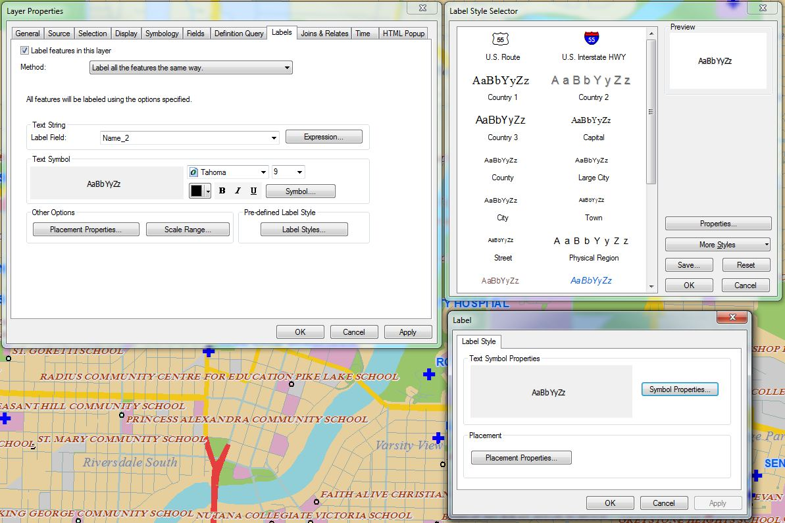
1
3
Figure 5: Label properties and creating your own style

The Symbol… button from Box 1 and Symbol Properties… from box 3 will both take you to a “Symbol Selector” window which can then lead you to Symbol Editor. See Figure 7.
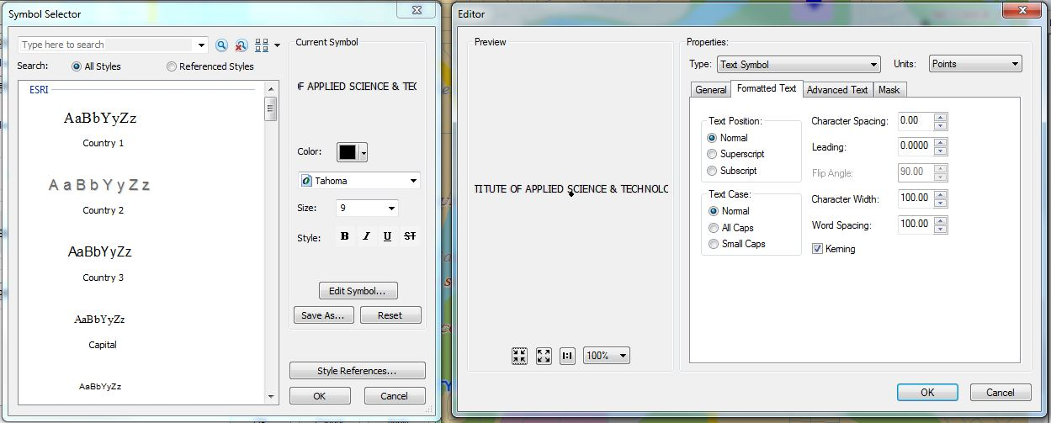
Figure 6: Symbol Selector and Editor boxes

Editor has four tabs: General, Formatted Text, Advanced Text, and Mask.
- General
  - Change the font, size, style (Bold, Italicized, Underline, Strikethrough)
  - X offset and Y offset (offset from the centre of the label point location)
  - Vertical alignment
  - Horizontal alignment
- Formatted Text
  - Text Position (Normal, Superscript, Subscript)
  - Text Case (If your field contains normal/proper case, you may change it to All Caps or Small Caps here. You generally cannot change the case if the text is upper case in the attribute table. This is why the previous link to field calculator tricks was provided.)
  - Character Spacing - Important to make labels readable and to better fill areas like the neighbourhoods.
    - Leading
    - Character Width
    - Word Spacing
    - Kerning
- Advanced Text
  - Text fill pattern
  - Text background
  - Shadow
- Mask (Halo)
  - Important if your label is similar in colour to a background colour, or if it may be placed near vertical or horizontal lines. In this example the halo colour is identical to the background colour.
  - NOTE* In order to determine the RGB values of the background (which is actually transparent by 18%), print screen the desired background colour in to a Paint document, and use the eye-dropper colour selection tool to find the RGB values. See Figure 8.
  - Save this colour in ArcMap if it is to be further used (see Figure 5).
This step should be done after the labels have been converted to annotation. Once labels are converted to annotation one has the freedom of choosing which labels to add a halo to and which to leave, as some labels may span over more than one background colour.
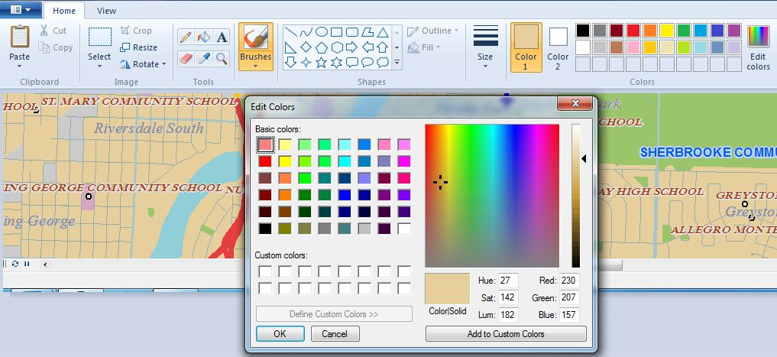
Eye dropper
HSV and RGB values

Figure 7: Paint document, showing the custom colour selection

After the labels have been fixed, some of the spacing and layout is still not quite right. In order to change labels from one-line text, to being spread over two lines, you must convert the labels to annotation. To do this, you want to make sure that there is a geodatabase ready to store the annotation.
To create a geodatabase:
- Catalog in ArcMap, right click on the folder you wish to create the geodatabase in → New→ Personal Geodatabase (see Figure 9).
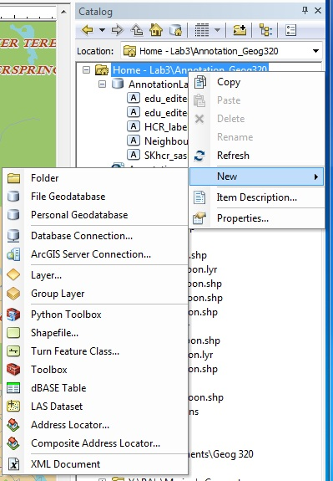
Figure 8: Create a Geodatabase

Converting Labels to Annotation:
- Right click on the layer you wish to convert in the Table of Contents→Convert Labels to Annotation→click on the folder symbol under “Annotation Feature Class”→ locate the geodatabase you created →name your annotation layer
- You can generally accept the default settings. Click convert.

Annotation

In order to edit the annotations you have created, you need to add the Editor Toolbar, Start Editing (go through the defaults or select your desired layer), click on the attributes tab (for editing later), and select the Annotation arrow.
Figure 9: Editor Toolbar, Annotation arrow in blue, attributes tab highlighted in red.

A “Create Features” window will appear where you can construct an annotation from one of the annotation feature classes you have created.
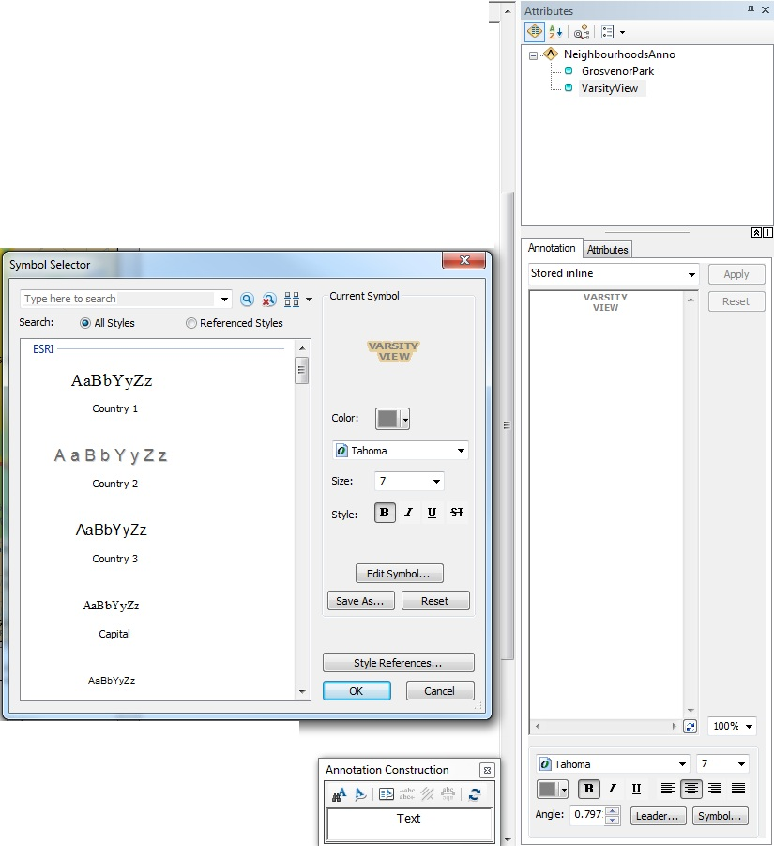
Figure 10: Editing Annotation Properties

In Figure 11, you can see that in the attributes tree, Grosvenor Park and Varsity View are selected. When you have the annotation arrow selected, right click your desired layer in the Table of Contents → Selection→ Make This the Only Selectable Layer.
- You can then choose more than one annotation to edit when you create a box around them with the annotation arrow.
You can see in Figure 11 that the Symbol Selector box has shown after clicking on “Symbol” in the Attributes tab of Annotation. The same properties are available for Annotation as were for labels, in Figure 7. In Figure 11 Varsity View has a halo around it.
If you are happy with symbol properties that you have changed, and you wish to re-use that style multiple times, you can save the style by choosing “Save As…”. This will save time rather than changing all of the labels and creating another annotation feature class.
Splining Annotation
To create curved “splined” annotation to better follow a feature or fill a space:
- Create Features → Construction Tools → Curved. You can also create a horizontal, straight, follow feature, or leader annotation.
- Type your desired text in the construction box and click as many times as needed to create the desired curve. It will take a few attempts to create the desired curve shape.
- Do not forget to edit the annotation properties while in the Attributes tab.
- It may be desirable to create multiple splines along a water feature, however with the correct amount of character spacing and word spacing multiple splines may not be necessary.
To modify the curve of the spline, rather than delete the construction, right click on the annotation while it is selected →Edit Baseline Sketch. When you are finished, right click on the annotation again→Finish Baseline Sketch.
To delete a splined annotation, right click on the item in the Attributes table after it has been selected→ delete.

