Guide to Editing Map Legends

Map legends explain map symbols and are crucial to the communication of a map’s message. Effective legends are created with careful consideration of labels and text, classes, colours, as well as mapping design principles. This document provides some basic principles of legends as well as how to use ArcMap tools to create and edit legends. Figure 1 below shows a finished map with an edited legend above a default legend which has not been modified. This document will go through how to edit this default legend as well as introduce the various options of legend editing.

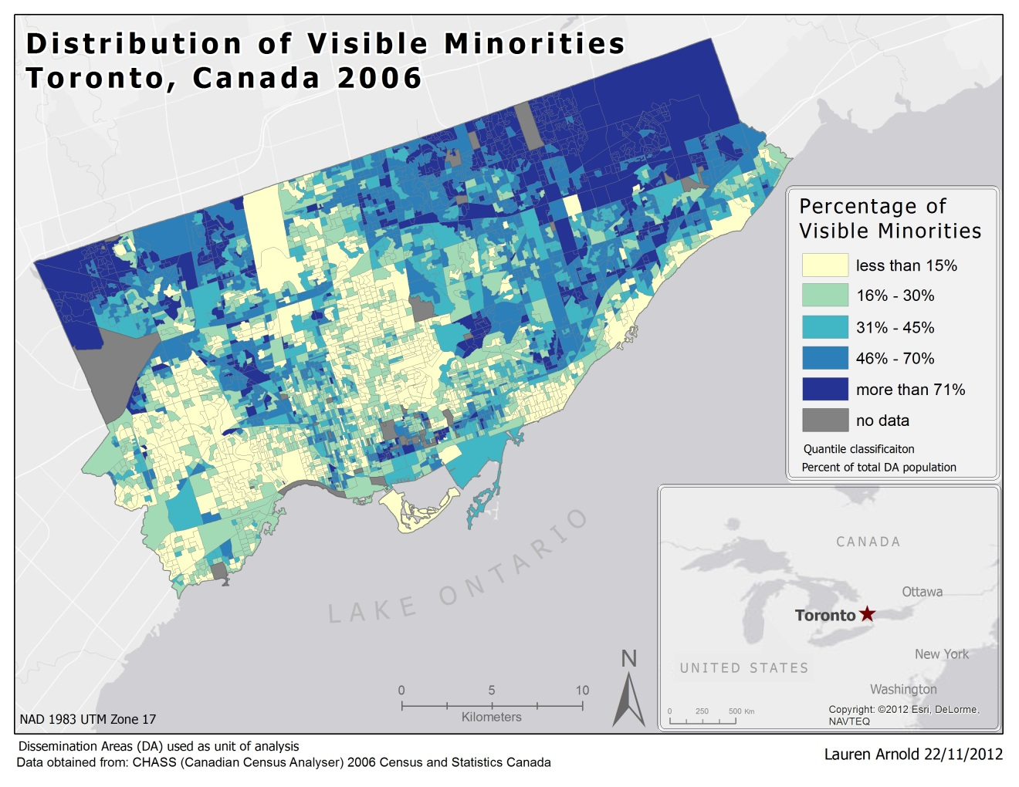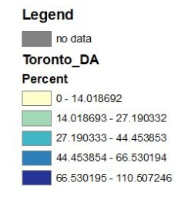
Figure 1: Final edited legend compared to a default legend

Inserting a Legend

Legend insertion and editing is done in layout view. When you click “Insert” “Legend…” the first prompt in Legend Wizard asks you to select the layers from your table of contents that you want to be included in the legend. Depending on the type of map you are making you may have several layers to choose from. Figure 2 shows the selection of map items screen. The arrows highlighted by the red box are used to add or remove items from the legend.

Note: It is possible to make more than one legend for a map. This may be a viable option if you are representing different types of features (e.g. points as well as areas) but you can also use multiple columns within one legend or vertical gaps to specify different types of symbols using Legend Editor.

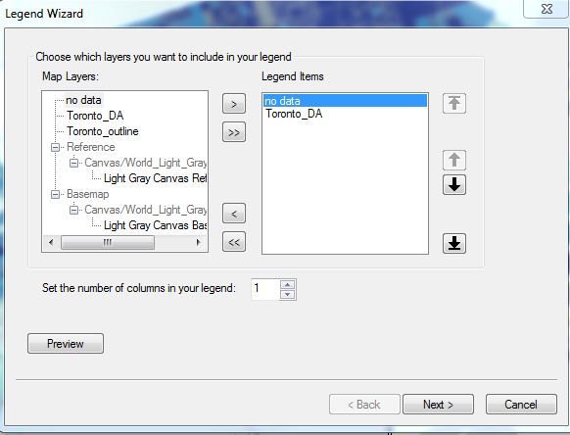
Figure 2: Selecting legend items

Once you have selected the legend items Figure 3 shows what the legend would look like if you simply click “next” through all of the remaining screens and then “finish”.

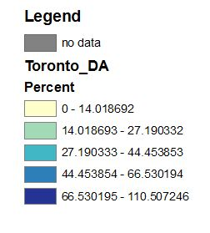
Figure 3: Default legend
Editing Legends in Layer Properties

There are several ways that this default legend can be improved without directly editing the legend itself and instead editing symbology.

- Open the symbology for the layer that corresponds to the legend using the table of contents. Here you can edit the labels and class divisions. Classification should accurately reflect the information and the labels for the classes should be clear and intuitive (whole numbers are best for most maps). By right clicking the class labels and choosing “format labels” (Figure 4) you can specify what kind of number the labels are (numeric, percentage, rage, direction, etc.) and then open up the numeric settings (Figure 5) and decrease the number of decimal places.

- On the main symbology screen you can slow click the labels to change the divisions and add words like “more than” and “less than” (shown in Figure 6). Once you have chosen your settings click “ok” and the changes will be reflected in the legend
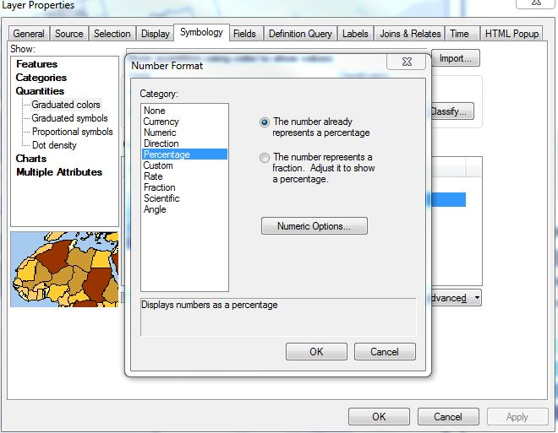
Figure 4: Format Labels in Symbology

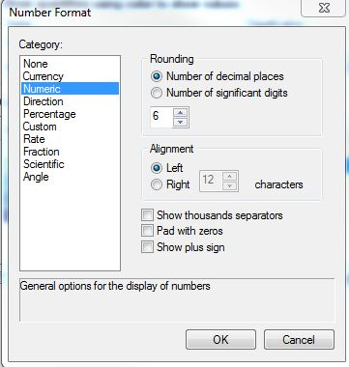
Figure 5: Numeric Options

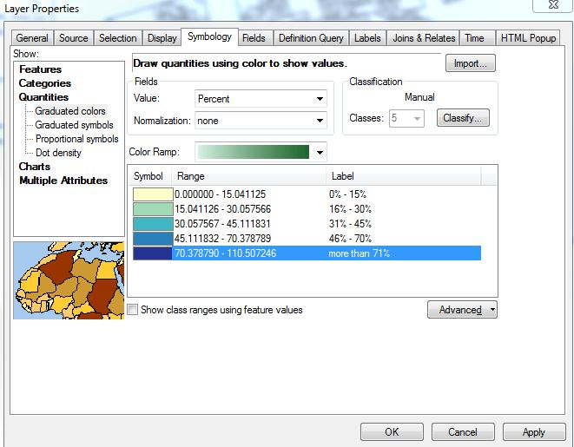
Figure 6: Changing label names in Symbology

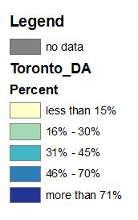
Figure 7: Result of editing symbology
Editing Using Legend Editor

To edit the aesthetic characteristics of the legend, right click on it in layout view and open the properties window. There are 5 tabs in the Legend Properties window: General, Items, Layout, Frame, and Size and Position. This section will outline the various options and tools in each tab.

General

- In this tab you can type in a legend title. A general rule is that the title of your legend should never be “Legend”; it should communicate something about the map and what the symbols represent without duplicating the map title. You can also set the font and text settings (character spacing, font, size, colour etc.) for your legend title by clicking “symbol”. It is possible to make your legend title appear on more than one line by pressing the enter key where you want the new line to begin.

- You can change the order in which your layers appear on the legend and add or delete layers from the legend. In this particular example there is a “no data” layer that should appear below the other symbols on the legend and this can be accomplished by using the up and down black arrows on the right side (Figure 8).

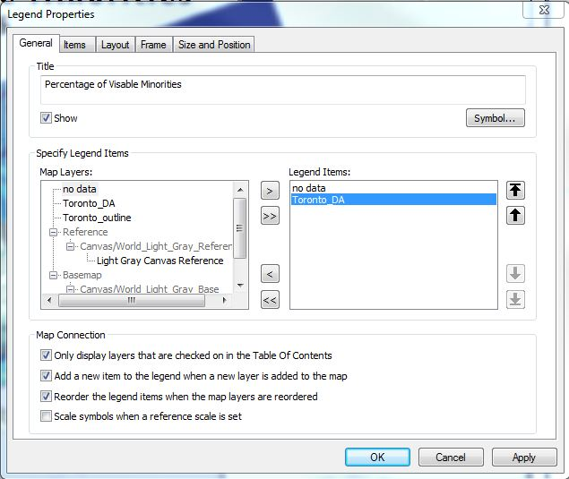
Figure 8: General Tab

Items

- The items tab in legend properties is where you select the style of your legend and edit the legend items. You can set the font properties and character spacing for the classes by clicking the symbol button. You can also set the number of columns by typing into the columns count box (Figure 9).

- Clicking on the “style” button opens the window displayed in Figure10. There are many style options to choose from. You can select styles which exclude the layer names or the class labels, or which display the classes horizontally instead of vertically. Keep in mind that if you choose a style that includes the layer names you can change the names in your table of contents to make them more useful. Experiment with different styles to determine the best style for your map. If you find a style that you like you can save it for future use using the save button. Notice that you can set different styles for different map layers if you like (apply settings to selected items) or apply to all layers by selecting them all.

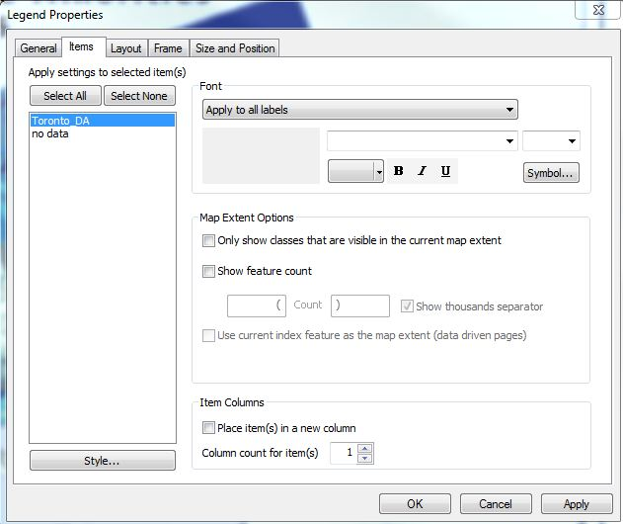
Figure 9: Items Tab

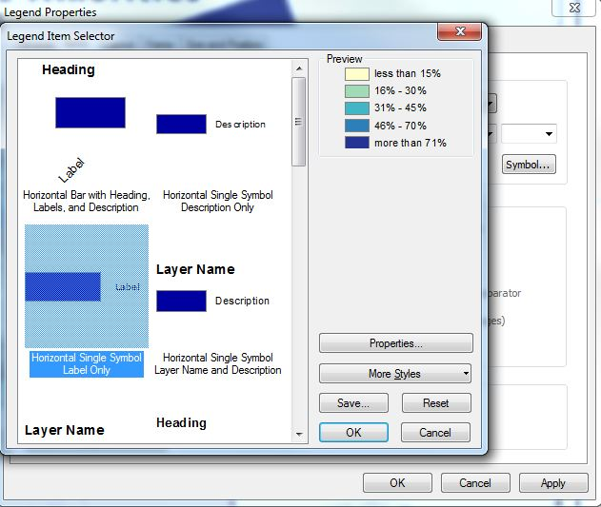
Figure 10: Selecting legend style

Layout

- In the Layout tab in the legend properties you can change gap spacing between legend items to further customize the style of your legend. If you click on the various entries in the gap table a red arrow indicator will show which spaces would be altered (Figure 11). You can change the defaults by typing numbers into the column on the right. There are many possible options for using gap settings. For example, if you want to make your legend entries look continuous, like in Figure 12, you can decrease the vertical gap but maintain the item gap (gap between the different layers). Increasing the title gap could be useful if you want to insert a text box into the legend later with information about the legend (Figure 12 “percent of total DA population”).
Note: when experimenting with gap settings it is helpful to keep in mind the original gap values so that you can revert to the original settings if you like.

- Text wrapping is useful if you need to fit your legend into a narrow area in the layout and have longer class labels.

- Fixed frame is used to maintain your legend size as you move it around in layout view.

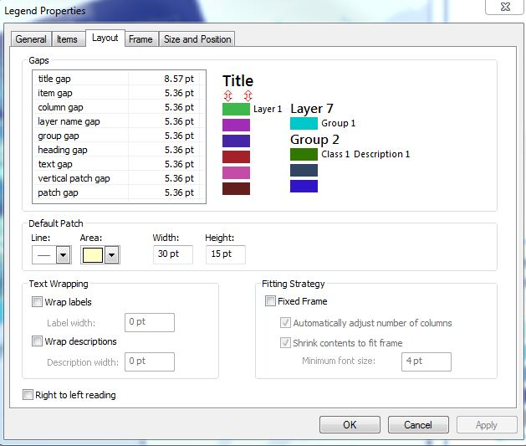
Figure 11: Layout tab

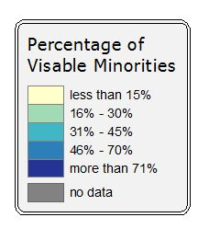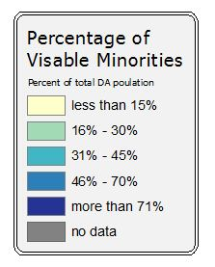
Figure 12: Examples of using different gap settings

Frame

- In the frame tab you can set borders, backgrounds, and shadows. If you choose to use a border you will likely need to set a gap (x and y) to create enough space between your border and your legend text. Rounding can also be set.

- If you choose to use a background fill you need to set the same gaps and rounding as your border so that they line up.

- Drop shadow creates a shadow behind your legend and allows you to set the x and y offset of the shadow.

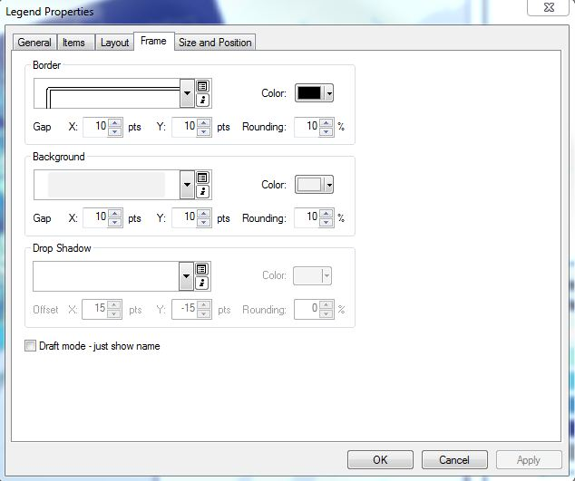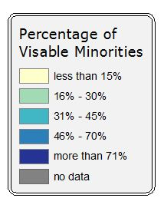
Figure 13: Frame tab and a legend using a border and background

Size and Position

- In this tab you can set a specific position where you want your legend to appear in your layout as well as the width and height (resizing and alignment can also be done manually in layout view using grid guides)

Additional Editing Options and Considerations

Layout tools

Once you have experimented and chosen all of your settings through legend editor additional editing can be done outside of the legend properties. For example, in Layout view you can insert text boxes with information about the classification, units of analysis etc. You can resize and move the legend in layout view using your mouse. You can also right click the legend and use the align tool if you want it to be aligned to a specific border or element of your map. If you have set layer transparency you can ensure that it is reflected in your legend by opening up the properties of the Data Frame and checking “Simulate layer transparency in legends” under the General tab.

Converting to Graphics

Another option, if you want to do specific editing, is to “convert to graphics”. This dissociates the legend from the layers in your table of contents. This allows you to specifically edit the symbols and labels independently from each other and resize the frame and border independently from the legend entries. Some examples where converting to graphics may be useful could be if you run into colour contrast issues between your map and legend, if you want you legend symbols to have outlines but not your map symbols, or if you want to reposition individual symbols or text within the legend. The gap at the bottom of the legend in Figure 15 that makes room for the text boxes was created by converting to graphics.

- To convert to graphics right click on your legend and click “convert to graphics” and then continue to right click and choose ungroup until you have separated the legend elements (Figure 13)
- Edit specific legend elements by right clicking and opening properties and symbology.
- You can group the legend elements back together by selecting them, right clicking, and choosing group, so that you can move the entire legend around easily.

Important Note: You should only convert to graphics as a last step in the map creation. By converting to graphics you dissociate the legend from the layers in the table of contents and any subsequent changes you make in layer symbology will not be reflected in the legend. For example, if you wanted to change your map’s colours you would have to manually reset the legend colours.

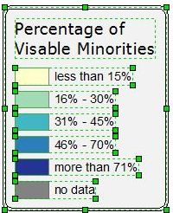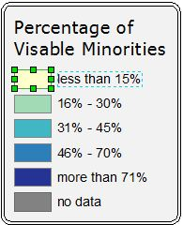
Figure 14: Converting to graphics and ungrouping legend elements

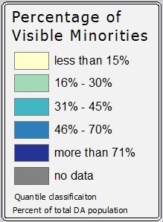
Figure 15: the final legend included in the map in Figure 1

For additional help:

http://resources.arcgis.com/en/help/main/10.1/index.html#//00s900000023000000

http://resources.arcgis.com/en/help/main/10.1/index.html#/A_quick_tour_of_page_layouts/00s900000007000000/

