Raster Data Manipulation
We will use several raster processing tools to create an index of farm land vulnerability to fracking development in Southwestern Pennsylvania. This is a version of a Multi-Criterion Evaluation, or MCE. Criteria we will use includes farmland’s distance to highways, farmland’s distance to already existing wells, and the slope of the land to find areas at highest risk for development.
- Download the raster lab data from the CGA website.

- Open the frack.mxd
The datasets loaded include:
- UnconventionalWells: point locations of current or permitted wells in PA
- Counties: polygon shapefile of 8 counties in PA
- Dist2Wells_r: a reclassified raster based on the Dist2Wells raster with values from 0 – 5, 0 being not possible for new wells to 5 being most possible.
- Dist2Hwy_r: a reclassified raster based on the Dist2Hwy raster with values of 1 – 3, 1 being least possible for new wells to 3 being most possible.
- NLCD_AG: a reclassified raster based on the NLCD raster showing agricultural land in this 8 county area.
- DEMs: a digital elevation model raster for this 8 county area.
- NLCD11: a raster showing land cover for this 8 county area.
- Dist2Wells: a raster calculated from the wells data indicating the distance to the nearest existing well. See “Pre-processing steps” below for information on how it was created.
- Dist2Hwy: a raster calculated from a highway polyline shapefile indicating the distance to the nearest highway. See “Pre-processing steps” below for information on how it was created.

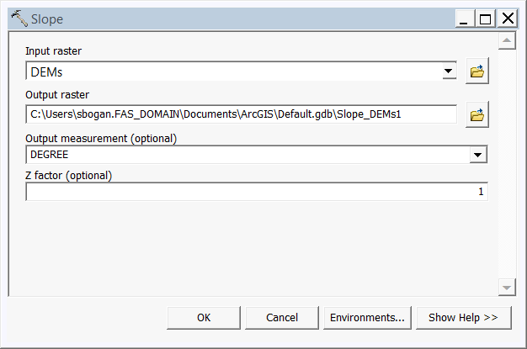
- First, we will calculate the slope from the DEM. From ArcToolBox, open Spatial Analyst Tools > Surface > Slope. The input raster is DEMs. Choose to save the output raster in the Frack_PA_data geodatabase and give it a name. The output measurement is DEGREE and the Z factor is 1. Important note: if your DEM x and y values are not the same as the elevation values, you will need the Z factor. See “Show Help >>” for more information.

- Next, we will reclassify the Slope raster to indicate the most favorable land for development. From ArcToolBox, open 3D Analyst Tools > Raster Reclass > Reclassify.
  - The flattest slopes are most favorable, so they get the highest score. Slopes over 20 degrees are considered not useful for the purposes of this exercise. This tool is picky about the spacing of the Old Values. You must have a space between each number and the “-“.
Reclassification Table
Old values | New Values
0 – 5 | 3
5.0001 – 10 | 2
10.0001 – 20 | 1
20.0001 – 58 | 0
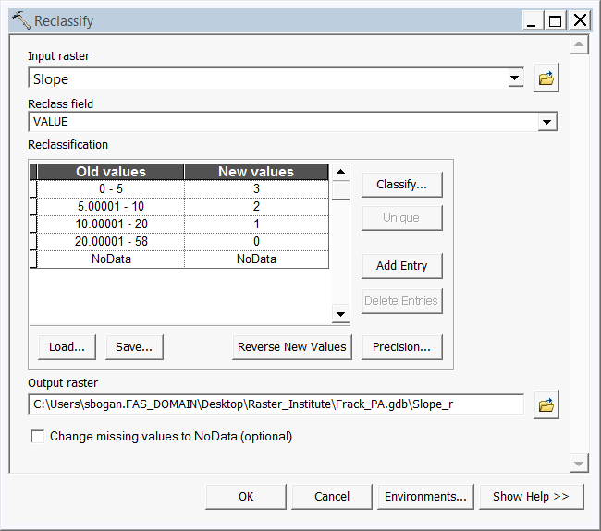

- Now that all of our data are in a scale from least to most likely for development, we can use the Raster Calculator to perform raster math to create our suitability map. From ArcToolBox, open Spatial Analyst Tools > Map Algebra > Raster Calculator. We will multiply each of our variables: slope_r * Dist2Wells_r * Dist2Hwy_r * NLCD_AG.

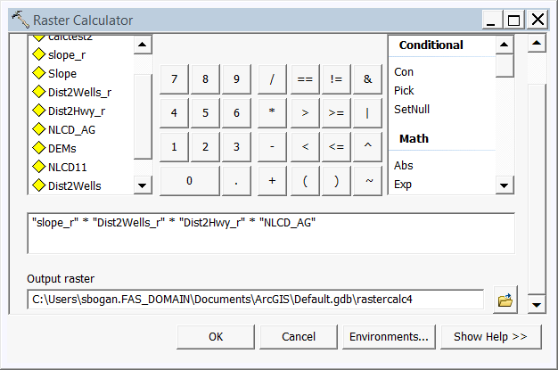

- Optional: Which counties have the highest risk of more well development? We can use Zonal Statistics to calculate the mean index value per county. From ArcToolBox, open Spatial Analyst Tools > Zonal > Zonal Statistics as Table.
  - The input raster or feature zone data can be a raster or a polygon. Enter Counties for our zones.
  - Zone field is a unique identifier for the zones. Use COUNTY_NAM.
  - Choose a location and name for your output table.
  - Choose MEAN as the statistic type.
When this tool is finished, it gives you a list of the counties with the mean index value for each. This can then be joined onto the county shapefile for symbolizing.

Data Sources:
UnconventionalWells: Carnegie Museum of Natural History. 2016. http://maps.carnegiemnh.org/index.php/projects/unconventional-wells/

DEM: The National Elevation Dataset (NED). USGS.
http://viewer.nationalmap.gov/basic/?basemap=b1&category=ned,nedsrc&title=3DEP%20View

NLCD11: Multi-resolution land characteristics consortium. 2011
http://www.mrlc.gov/
Counties: Pennsylvania Department of transportation. 2012
http://www.pasda.psu.edu/uci/MetadataDisplay.aspx?entry=PASDA&file=PaCounty2012_01.xml&dataset=24

Pre-processing information:

The Euclidian Distance tool was used to calculate Distance to wells, and then the distance was reclassified.
Distance to existing wells reclassification table
5: 16,000 m – 20,000 m
4: 12,000 m – 16,000 m
3: 8,000 m – 12,000 m
2: 4,000 m – 8,000 m
1: 100 m – 4,000 m
0: 0 – 100 m

The Euclidian Distance tool was used to calculate Distance to highways, and then the distance was reclassified.
Distance to highways reclassification table
3: 0 m – 500 m
2: 500 m– 4000 m
3: >4000 m

